Seeklight Processing Workflow

Background
JSTOR’s Seeklight outputs records using Dublin Core as the schema and encoded in Excel spreadsheets. For our purposes, it is best to convert these records into MARC before loading them in Alma. We developed a Python script that will accept the Seeklight export(s) and PDFs of documents, generating a new Excel spreadsheet with data in MARC21 for loading into Alma. The general process follows three stages:
- Process Seeklight export(s) and PDFs in Python
- Import records and files into Alma using the Digital Uploader
- Manually review load and update records

Requirements
- Seeklight_Processing.py
- Python

Process

Preamble: Seeklight_Processing.py
Seeklight_Processing.py is the Python script developed to convert the records from DC to MARC. The script is available in in its most up-to-date version in GitHub. The script accepts a whole folder of files and runs them through several processes. Once installed, the script should run simply by click-and-point, but I’ll lay out the basic structure and process here for reference:

Structure
Python scripts are composed of functions, which are repeatable blocks of code that are called to run specific processes. Each block that begins with “def <function name>(<inputs>):” is a standalone function. The most important function, which acts as the control for the whole process is the main() function.
Python also makes use of something called libraries or modules, pre-written packages of code that can be re-used for common procedures. The block of text at the top of the script listing “imports” includes the modules required to run the code. These modules enable things like finding the size of a file (hurry.filesize), getting the current date and time (datetime), or displaying messages and prompting users to select files and folders (tkinter messagebox and filedialog). The second file in the GitHub repository, requirements.txt, includes a list of these required modules and their versions. It is used during the install process to ensure that all the code’s dependencies are correctly installed before attempting to run.

Processes
The following flowchart lays out the basic structure of the code:
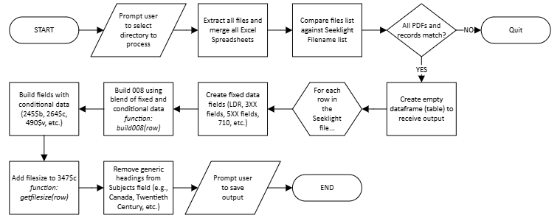

Installing Seeklight_Processing.py
Running Seeklight_Processing.py requires that Python be installed on the computer. IT can help with setting this up.
Once Python is installed, the following process can be used to install Seeklight_Processing.py:
- Go to https://github.com/kevintburke/seeklight-processing
- Under “Code”, click Download ZIP
- Extract the files to your desired location
- Navigate to your chosen directory in File Explorer
- Right-click and choose “Open in Terminal”
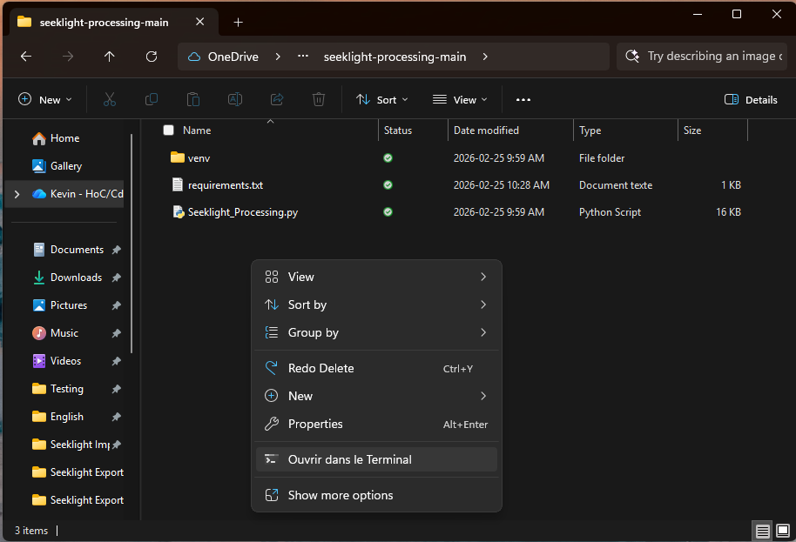
- In the Terminal, enter the following instruction and hit enter: python -m pip install -r requirements.txt
- Once the requirements are installed, close the terminal
- In File Explorer, right-click on Seeklight_Processing.py, click show more options, and create a shortcut on the Desktop
- Double-clicking the shortcut should run the program. If not, you may need to change the default “open with” to Python.

Running the Process

Process Seeklight Export(s) and PDFs in Python
- Zip and download all Seeklight exports and PDFs from EDRMS
  - NOTE: This process can handle up to 1000 files at a time, so multiple batches can be easily combined by putting the files in the same folder
  - Downloading files through the browser may trigger EDRMS’ filesize limits. If this happens, files can be downloaded by accessing EDRMS through File Explorer (Enterprise Connect > edrms > Enterprise > IC > Digital Collection > canadaparliament > SessionalPapers > Seeklight). Sending the whole folder for the desired upload to the desktop (right click > Send to > Desktop location…) is the easiest way to retrieve all the files in one go.
- Extract the files to your chosen directory
- Run the Seeklight_Processing.py script by double-clicking the desktop shortcut or by navigating to its directory in File Explorer, opening a Terminal (see above), and entering the command “python seeklight_processing.py”
- When prompted, select the directory including the Seeklight export(s) and PDFs
  - NOTE: The script will automatically check to ensure that all PDFs have a record and vice-versa. If mismatches are found, the script will quit.
  - NOTE: The script will flag any files that are not PDFs (.pdf or .pdfa) or Excel spreadsheets (.xlsx). If you have other files present in the directory, it may cause issues with the process, so moving them to another directory or creating a subfolder to “hide” files is recommended.
- The script should run automatically, following the process described above
- When prompted, save the output in the desired location

Import Records and Files into Alma Using the Digital Uploader
- In Alma, navigate to Resources > Advanced Tools > Digital Uploader
  - NOTE: This requires at least one of the Digital Inventory roles (Digital Inventory Operator, Digital Inventory Operator Extended, and/or Collection Inventory Operator)
- Ensure “Insert into” is set to Sessional papers (Seeklight Import profile)
- Click “Add New Ingest”
- In the dialogue that opens, set a unique name for the upload (e.g., the date and initials, 20260225-KB)
- Click “Add Files” and select all PDFs and the output of the Seeklight_Processing.py script
  - NOTE: Alma will match the PDF to the record using the data in the 988$a. If there are any PDFs missing, records without representations will be created. If there are extra PDFs, they may be attached to records with similar filenames (Alma will do close matching on filenames, assuming that the filename includes prefix and suffix; this can cause issues with faulty matching in sessional papers which have similar numbers if there is no exact match available.
  - NOTE: Ensure that only the output of the Python script is included; any other Excel files may cause errors as they are not formatted correctly
- Click “Upload All” and then click OK to close the dialog
- Select the Ingest you just created and click “Submit Selected”
- Click Run MD Import
  - NOTE: As part of the loading process, the normalization rule “Seeklight Import” will be run on the incoming records. This includes steps such as adding the 710$e, correcting indicators in various fields, splitting subject headings into unique instances of 650, etc.
- Monitor the import to ensure all files are correctly imported and representations are associated with records
  - NOTE: The loading process is set to use JSTOR’s SSID as the unique identifier for records. Incoming records with the same value in the 035$z with the prefix (JSTOR) will be rejected
- Navigate to Resources > Imports > Monitor and View Imports to monitor the progress of the import and see the accepted and rejected records/files after completion
- Ensure all records have an associated representation (search the Digital Titles index for records with an MMS Creation Date of today and where Has Inventory equals No)

Historical Sessional Papers Only
Historical sessional papers typically include a / in the sessional paper number. Since this character cannot be used in filenames, and we populate the MARC record with the filename instead of the sessional paper number, several fields will need to be updated after loading the records into Alma. The following process will ensure that all historical sessional paper numbers are updated as needed. The normalization rule is set to replace the sixth character of the sessional paper number in the 055$b, 245$b, 490$v, and 830$v with “/” if the string follows this regex: (.{5})-(.*). This rule will leave the 988 field untouched, meaning it will still contain the unaltered filename in case it is required for future matching.
- Create a set with all the records uploaded (or, if the number is small enough, select run a job when viewing the uploaded records)
- Run a manual job (Admin > Manage Sets and Jobs > Run a Job) and select the job “KB - MARC21 Bib Normalization Placeholder” (note: NOT KB - MARC21 XSL Bib Normalization Placeholder, which is for XSL normalization jobs ONLY)
- Choose the correct set for processing
- Select the Drools File Key “KB – Swap / for – in Sessional Paper #”
- Run the job

